27.05.2009
Name :
Number :

CEM 123 DIGITAL LOGIC

(25) |  | Design a synchronous state machine with the state/output table shown in following table, using D flip-flops. Use two state variables, Q₁ Q₀ with the state assignment A= 00, B=01, C=11, D=10.  Draw the chart. Is it Moore or Mealy type? Explain.
  Present State | Next State |  | Output
  Present State | X=0 | X=1 | X=0 | X=1
  A | B | D | 0 | 0
  B | C | B | 0 | 0
  C | B | A | 1 | 1
  D | B | C | 0 | 0
(30) |  | Analyze the synchronous state machine in the following figure. Write the next state functions ( D₁=? D₂=?), state table and draw state diagram (use state names A-D for Q₁ Q₂ = 00 -11).  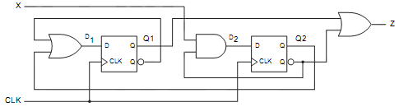
(30) |  | Design a synchronous counter using JK flip flops. The counting sequences is 1 → 0 → 3 while input x equals “0”. When x becomes “1” the sequence is 1→ 3 → 0. Determine the behavior of the circuit for unused states.
(15) |  | Draw the timing diagram and explain the function of the circuit.  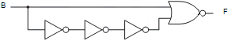  B  F

